Changelog

|  |  |  |  |
| --- | --- | --- | --- |
| **Date** | **Time Spent** | **Changes** | **Goals** |
| Fri Jan 2 10:18:38 2015 -0500 | 5h | * Wrote initial physics framework with classes for entities * Wrote vector class * Wrote basic circle collision code * Wrote basic graphics for drawing entities * Created basic menu structure, keyboard navigated * Remove repeated code and useless things * Write documentation | * Get graphics working * Get rectangle physics and bounding box physics working * Add better graphics * Level management and loading |
| Sat Jan 3 15:15:56 2015 -0500 | 5h | * Added methods to get collision states of an Entity, instead of putting all collision code in the Physics Engine * Fix some improperly implemented collision algorithms * Change game background image * Write documentation * Added ToggleMenuItem for menus * Added level management system and levels, and created test levels | * Get menu graphics working * Improve level management * Improve physics * Write scoring system |
| Sun Jan 4 14:42:32 2015 -0500 | 2h | * Change level select to be more efficient and visually appealing * Made level class to organize levels * Made the level manager use Java Properties | * Make the game actually load the levels to visually work * Improve physics * Write scoring system * Get game graphics working |
| Mon Jan 5 13:21:14 2015 -0500 | 1.5h | * Made physics engine load levels properly * Added documentation | * Write scoring system * Get menu graphics working better |
| Tue Jan 6 09:03:19 2015 -0500 | 1.25h | * Correct circle physics * Fix entity creation code * Fix implementation of gravity * Fix drawing of shapes to reflect their actual location | * Write scoring system * Implement pause menu * Efficiency tweaks |
| Wed Jan 7 09:22:14 2015 -0500 | 3h | * Corrected rectangle physics * Implemented a working but ugly pause menu * Added rectangle with wall collision | * Implement better graphics for menu and game * Write scoring system |
| Thu Jan 8 13:59:19 2015 -0500 | 3h | * Made rectangles rotatable * Implemented level background color setting | * Implement scoring system * Implement better graphics * Fix physics with rotatable rectangles * Add music |
| Fri Jan 9 16:44:50 2015 -0500 | 1.5h | * Added music * Added configurable settings * Added menu “listeners” to reduce code in keyPressed() | * Add an icon * Make menus mouse controllable |
| Sat Jan 10 18:50:13 2015 -0500 | 2h | * Made entity collision and drawing more abstract so that multiple if statements are not required to do tasks, instead entity.doTask() can just be called, and each entity handles them individually | * Add an icon * Make menus mouse controllable |
| Mon Jan 12 09:03:48 2015 -0500 | 3h | * Added an icon * Fixed menu design * Fixed some minor physics bugs * Improved rectangle collision with wall angle collision * Added an image for the actual trebuchet | * Make trebuchet image scale properly * Implement rectangle to rectangle collision |
| Tue Jan 13 09:31:04 2015 -0500 | 1.25h | * Scale trebuchet graphic * Added rectangle to rectangle collision detection * Removed the useless EntityType class which was deprecated due to not being used in any classes at all | * Optimize physics and remove redundant checks |
| Wed Jan 14 10:07:53 2015 -0500 | 5h | * Completely removed rectangle physics, except with projectiles, since they are difficult to implement * Made physics checking and resolving completely abstract * Added AABB to Circle collision detection * Added more collision possibilities to test for * Removed extra classes which were empty * Removed some debug code * Moved AABB collision detection to the MathOperations class to make it more accessible * Wrote documentation * Added an abstract method in Entity to get all points in the entity | * Add targets to hit * Add AABB physics * Improve level loading redundancy |
| Thu Jan 15 10:10:06 2015 -0500 | 1.25h | * Improved level loading to use methods and not redundant * Improved debug logging | * Add some levels * Add projectiles |
| Fri Jan 16 08:54:51 2015 -0500 | 1.25h | * Rename entity classes and Vector so they don’t conflict with java.awt.geom * Added more levels * Added projectiles instead of firing circles | * Make menus clickable * Finalize rectangle physics |
| Sat Jan 17 18:17:40 2015 -0500 | 6h | * Finished rectangle physics and squashed many bugs * Completely recoded menus to make them clickable * Made MenuItemAction interfaces for MenuItems to own their own actions instead of menus owning the actions | * Add new menu graphics * Work on highscore system |
| Sun Jan 18 18:13:00 2015 -0500 | 8h | * Work on appealing menus * Work on nice images * Work on finalizing level loading system * Added highscores system * Added scoring system * Added realistic tileable textures * Added more levels * Added a level editor | No more goals |
| **Total** | **50h** | **3,036 code additions and 2,128 code deletions, 52 file changes, and 40 commits** |  |

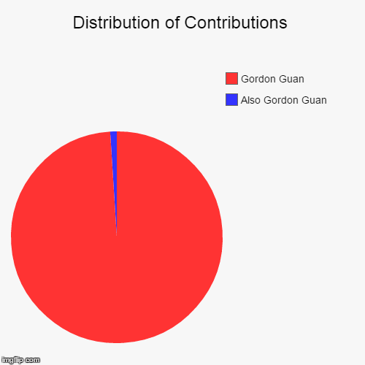

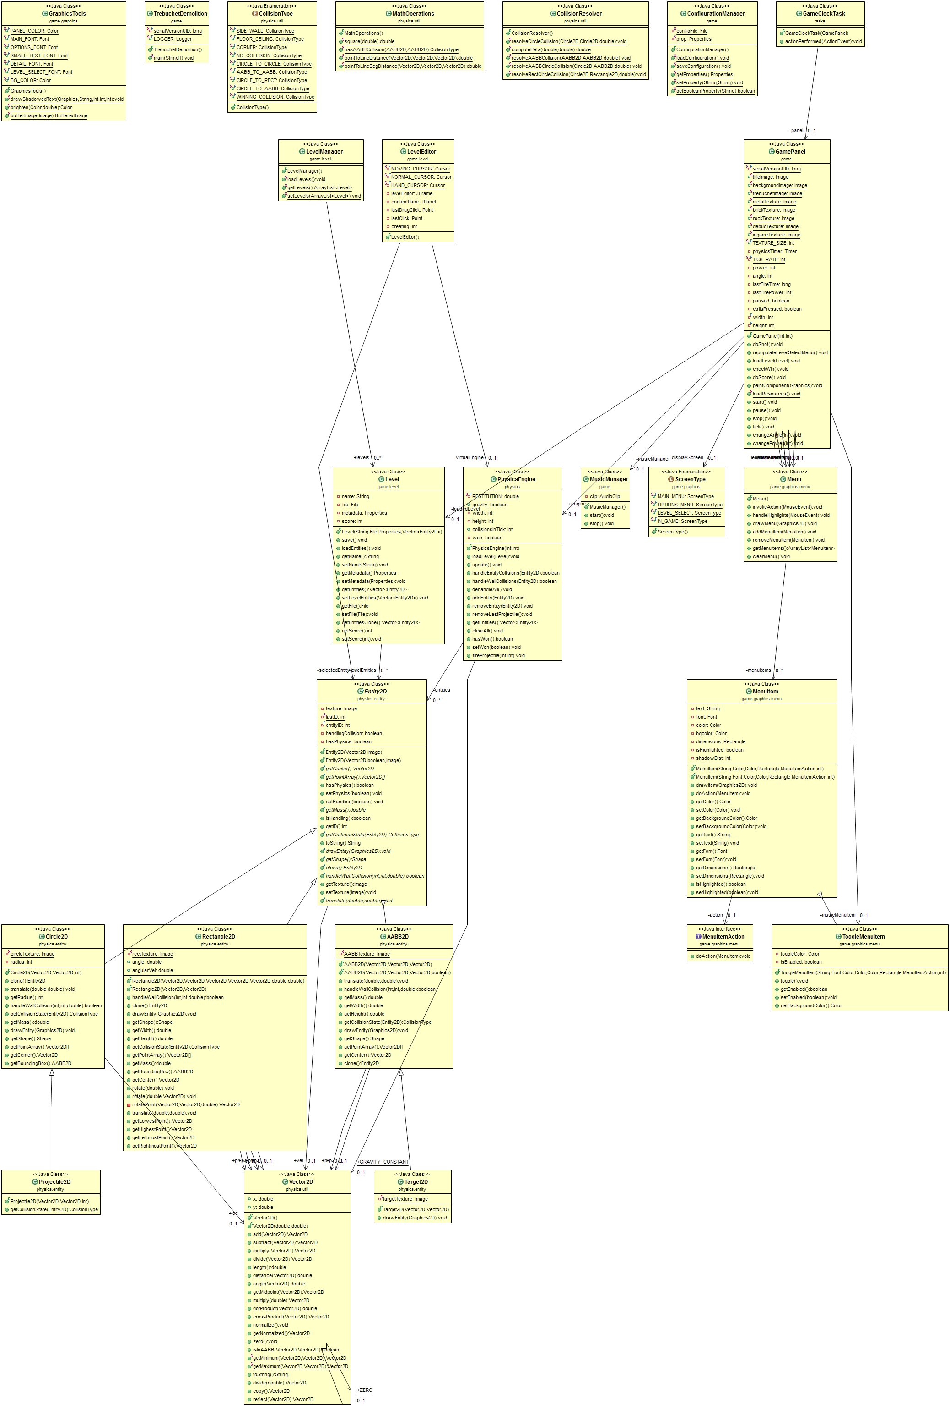

**Trebuchet Demolition v2.0 UML Diagram**